Infection Control Task Force (of COVID-19 MH Consortium)
Includes Mask Task Force and Infection Control Procedures Work Group

Members: Jacqueline A. Hobbs, MD, PhD (Chair); Elizabeth Ahn, MD; Marcia Bailey, BSN, RN-BC; Lara Dowling; Roxane Harcourt, LCSW, LMFT; Ryan Joy, MD; Nicholas Martinez, MD; Meena Nuthi, MD; Priscilla Spence; John Repique, DNP, RN; Joe Thornton, MD
Table of Contents (Click on items to go directly to section)
Top Things to Do to Protect Yourself and Your Patients in the Hospital and at Home 1
Best Practices for Inpatient Psychiatric Care During COVID-19 Pandemic 2
Important Phone Numbers for Questions 2
PPE: Current as of 5/08/2020 2
Clothing 11
How to Clean Your Phone and Smartwatch 12
Protection at Home (see Appendix for more info) 13
Protecting Your Food 13
Travel 13
APPENDIX: Further detailed information to supplement above: 14
TRAINING VIDEOS 17
The Mindful Gator Quick Infection Control Tips 19
The Mindful Gator Infection Control Basic Skill Checklist 20

Top Things to Do to Protect Yourself and Your Patients in the Hospital and at Home
- Prior to interacting with a patient, please do a thorough chart review to see if any contact/airborne precautions? If so reach out to RD/attending for further instructions. Once at the room, please look for precaution signs and don appropriate PPE gear. When leaving, please remove the gear using sterile technique and wash hands with soap and water.
- Frequently wash your hands for 20 seconds (sing “Happy Birthday” song twice) with soap and water (UFPsychHWTutorial). If soap and water are not available and your hands are not overtly dirty then use alcohol-based hand sanitizers that contain at least 60% alcohol. Dry hands thoroughly and use the paper towel to turn off the faucet. You can check your technique using Glow Germ (UFPsychGGVideo).
- After washing your hands, please continue to avoid touching your eyes, nose, mouth and your face.
- Do not come to work if sick. Check with your supervisor if you have questions.
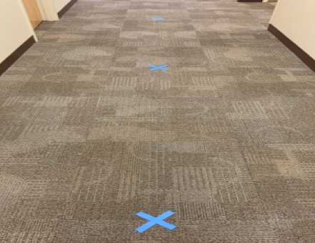
- Put surgical mask on patients with symptoms. This is the greatest way to reduce your/other risk. Do not put N95 masks on symptomatic patients.
- Practice social/physical distancing—keep at least 6 feet of distance between you and others (see picture).
- Wear a mask (see below).

For internal COVID evaluation for healthcare workers, call 352-559-2900 first. After which there will be a screening and then a telemed visit. If high risk exposure/situation your testing is a priority and will be done in house with results being available within a couple of hours.

Best Practices for Inpatient Psychiatric Care During COVID-19 Pandemic
http://alert.psychnews.org/2020/04/five-strategies-to-protect-patients.html

Important Phone Numbers for Questions
UF Health Command Center: 352-265-9000
(For coordinated management of the overall COVID-19 response in the hospital and a general resource for all faculty and staff)
UF Health COVID-19 Exposure Hotline: 352-265-5550
(Guidance for faculty and staff who may have been exposed to a COVID-19 positive patient)
UF Health Labor Pool: 352-265-6000
(Guidance for hospital staff with questions for redeployment)
UF Health Telehealth Triage Center: 352-559-2900
(Health care guidance for faculty and staff with questions about possible illness)
UF Health COVID-19 Peer Support information: 352-265-5459
(Mental health care guidance for faculty, staff and trainees with questions about counseling or other mental health treatment)

PPE: Current as of 5/08/2020
Updates from UF Health
5/07/2020
“Fit Testing for N95 Masks Relocated
Fit testing for N95 masks will be relocated to G1-011 in the north tower (Nursing Administration, across from Wendy’s) as of 5 p.m. today, Thursday, May 7. Hours of operation remain 24/7.

Fit testing is now co-located with the distribution site for N95 surgical masks for your convenience. Mask pick up also is available 24/7. If you have previously been fitted for a mask and require more, please remember to bring the card you received when you were fit tested designating the mask required.

5/06/2020
“PATIENT CARE CLINICAL GUIDANCE
Reminder: Masks and face covers now required in patient care and non-clinical areas
This is a reminder that UF Health Shands is requiring faculty, residents, staff and visitors to wear masks or face coverings in all public areas, inpatient care areas and hospital-based outpatient care areas. Visit the Bridge to learn more about this important mask policy update. Please note:
- This policy goes into effect Thursday, May 7
- Ear loop and cloth masks are acceptable unless a patient’s condition requires a higher level of PPE
- The policy is also in effect on shuttles and any locales where social distancing may not be possible”

5/05/2020
“Video Message from Ed Jimenez
UF Health Shands CEO Ed Jimenez has recorded a new video message discussing the UF Health Shands PTO Leave-Sharing Program, providing a PPE and masking update and emphasizing the importance of reviewing messages on the Bridge. View the video on the Bridge or see it on the UF Health YouTube channel.”
“Masks and face covers now required in patient care and non-clinical areas
UF Health Shands Chief Medical Officer Parker Gibbs, M.D., sent an email explaining that UF Health Shands is requiring faculty, residents, staff and visitors to wear masks or face coverings in all public areas, inpatient care areas and hospital-based outpatient care areas. Visit the Bridge to learn more about this important update.”

4/30/2020
“Safety Measures Taken at UF Hospitals and ERs
At UF Health, we have taken many steps to safeguard the health of our patients, visitors and caregivers throughout our hospitals and emergency rooms in Gainesville.
Visit the Bridge to access the flyer.”

4/27/2020
“New video message from Nicole Iovine, M.D.
Dr. Nicole Iovine, UF Health Shands Hospital Epidemiologist in Chief, demonstrates masking, handwashing and hand-sanitization procedures. View on the Bridge or our YouTube channel.”

4/25/2020
“NEW VIDEO MESSAGE FROM NICOLE IOVINE, M.D.
Dr. Nicole Iovine, UF Health Shands Hospital Epidemiologist in Chief, discusses therapeutics related to COVID-19. View on the Bridge, or on our UF Health YouTube channel.
VIRTUAL VISITS
Staying Connected: Tips for Virtual Visitation. For everybody’s safety during the COVID-19 response, UF Health has taken the responsible step to limit visitors to our hospitals. We appreciate that staying connected to loved ones can have a positive impact on a patient’s health and well-being. It’s important for family and friends to stay in touch and to be aware of a patient’s status throughout their care. Thanks to today’s internet and social media tools, virtual communication is easier than ever. Please remind patients to encourage family members and friends to take advantage of virtual visits with their loved one while they are in the hospital.
HOME CARE INSTRUCTIONS
Home Care Instructions for COVID-19 patients (in English and Spanish) have been moved to a new section, Home Care Instructions, on the Patient Care Clinical Guidance tab on the Bridge.”

4/22/2020
“NEW: PPE “how-to” videos
Infection Control has created six new videos to describe in detail the proper procedures for donning and doffing CAPRs, PAPRs and N95s with face coverings.
- CAPR (YouTube: Donning, Doffing)
- PAPR (YouTube: Donning, Doffing)
- N95 with eye protection (YouTube: Donning, Doffing)”

4/19/2020 (Message from Mr. Ed Jimenez, UF Health Shands CEO)
“In an effort to provide frequent updates on our current COVID-19 response efforts, UF Health Shands CEO Ed Jimenez has recorded a new video message. View the video on the Bridge or see it on the UF Health YouTube channel.”

4/17/2020 (Message from UF Health)
“A NEW VIDEO MESSAGE FROM NICOLE IOVINE, M.D.
Dr. Nicole Iovine, UF Health Shands Hospital Epidemiologist in Chief, provides details surrounding PPE use and options for disinfecting N95s. View on the Bridge here or on the UF Health YouTube channel.
FOLLOW UP TO MASK GUIDELINES
To follow up on yesterday’s recommendation that all UF Health faculty, residents and staff wear ear loop masks while in any patient care area, please note it is not necessary to change masks between patients unless the mask becomes soiled or damaged. You can find the original message here.”

4/16/2020 (Message from UF Health Shands CMO Dr. Parker Gibbs):
Universal Masking to Start 4/17/2020
“Recently the CDC and other organizations have recommended masking of health care workers to help prevent the spread of COVID-19 in the hospital setting. Although for weeks we have provided ear loop masks to all employees who want them, we are now strongly recommending that all UF Health faculty, residents and staff, as well as patients within our hospitals and practices around the community, wear ear loop masks while in any patient care area. If interacting with a person under investigation (PUI) or a true COVID-19-positive patient, you should continue to wear appropriate PPE.

Additionally, visitors who pass the screening upon entry to our UF Health facilities, and patients in our outpatient practices, will be asked to wear a face covering of some kind (not necessarily an ear loop mask). If they are not wearing a face covering, they will be required to wear one of our ear loop masks, which we will provide to them. Access Center staff will inform (by phone) UF Health Physicians outpatient practice patients of this information at the time of appointment scheduling, and information will be included on reminder calls. We will soon make this information available to the community through our COVID-19 UF Health Website.

If you need an ear loop mask for yourself or a patient, you can obtain one through your department leader starting Friday, 4/17/20. For UFHP practices, masks will likely be available starting early next week. Department leaders can replenish masks via PeopleSoft using order number 100094855. Masks will be delivered to each location from the Integrated Services Center (ISC). If you are manning a visitor screening station at a hospital facility, masks will be delivered to each location for distribution to any patient/visitor who needs one.”

4/14/2020 (Dean’s Town Hall):
- Fit-testing on 5th floor of North Tower (Rm. 5190); please come by for testing (24/7)
- Still no global requirement for staff to wear masks; must wear mask if exposed to someone who is positive or working in aerosol-generating procedures (NOTE: The department leadership highly encourage all staff to wear a mask)
- Tests can have false negative so always wear proper PPE

4/13/2020:
Reminder on reusing N95s
While our current supply of N95 masks is adequate, it is still important that we continue to conserve N95s during this time. To that end we are following guidelines developed by the CDC to reuse N95s. There are two methods that staff may utilize which can be found on the Bridge.

4/10/2020:
4/10/20: (UPDATED) COVID-19 Appropriate PPE Options

4/08/2020:
“Appropriate PPE Use
Information regarding appropriate use of PPE is posted on the Bridge at PPE options for N95 masks, non-N95 masks and eye protection. Please share this flyer with your staff and post it prominently in your department. As a reminder, N95 masks should not be worn outside of the scenarios referenced in the flyer. Most importantly, N95 masks should not be worn as an everyday mask throughout the hospital. The hospital has provided staff with procedure masks to be used when an N95 mask is not warranted.

N95 surgical masks and fit testing — Earlier today Dr. Gibbs sent out an important update about N95 masks and the need for fit testing for Safe Life surgical masks. 3M N95 surgical masks are now in short supply so staff will need to have a fit test for Safe Life surgical masks, even if previously fitted for a 3M N95 mask. For fit testing, please visit Nursing Education, Room 5190, in the north tower. Additional information can be found here.

Social distancing reminder — Please continue practicing social distancing with your co-workers in shared and common spaces. It is important that we keep each other safe just as we do our patients.”

4/07/2020
“As the COVID-19 pandemic continues, our supply of personal protective equipment, specifically N95 masks, has reached a point where we feel comfortable liberalizing our distribution to those health care workers and their units that are at higher risk of potential exposure. We will begin distribution of these N95 surgical masks this evening out of room G1-011 in the north tower (nursing administration across from Wendy’s). This site will be operational 24/7 until distribution is complete. Other distribution sites will open over the next two days.

We are asking those who have direct patient contact and work primarily in the areas of the Emergency Department (all sites), all ICUs, adult hospitalist medicine, ORs, Labor and Delivery and other invasive procedural areas to visit the distribution sites as their schedule permits. Those who work in areas not listed above should continue to wear ear loop masks until we can facilitate a second wave of distribution over the next week.

Each person will receive a number of masks (three or five) appropriate to the work they perform. We recommend the masks be used one per “shift.” Masks should be preserved and reused until visibly soiled or deformed. Each mask will be placed in an individual brown paper bag. The CDC has recommended that one acceptable method of decontaminating the masks after use is to place the mask in a dry paper bag and allow it to sit for five days after which time the virus will no longer be active. Thus, if one works five days in a row and has five masks in five bags, one should have a decontaminated mask available for every work day. At the outset we are asking everyone to be personally responsible for the care of the masks they are given and to preserve them throughout the month and longer if possible.”

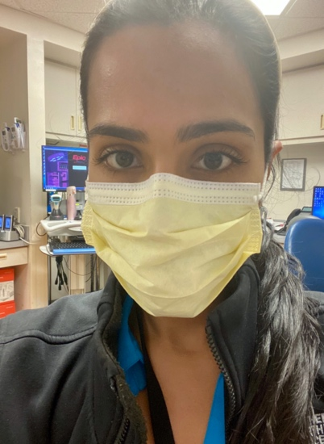
It is important to keep in mind that wearing earloop-style and/or N95-type masks does not replace the need to (1) practice frequent hand hygiene, (2) keep a 6-foot distance from others as much as feasible, and to (3) stay home if you develop a fever or any type of acute illness. When caring for a patient on airborne or modified airborne isolation, only an N95 mask or CAPR should be used. Please be aware that N95s and CAPRs are very limited resources and should not be worn for routine use.

A note on home-made masks. Anesthesiology is working on making standardized masks from materials used in sterilization procedures and will make them available to providers and staff. We’ll keep you posted as these become available. As of now, home-made masks are allowed per The Joint Commission and our hospital. Stay tuned. If you do use a home-made mask, please follow the same good practices for donning and doffing your mask and washing your hands as discussed below.

Proper PPE depends on your clinical location and whether there are contact or other precautions in place for a particular patient.

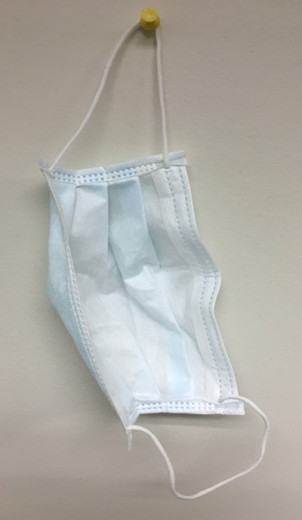
For most routine clinical care in the outpatient setting or general wards (where no precautions are in place), use a surgical ear loop mask continuously throughout the day. (Reference). If slippage of the mask off the nose tends to occur, consider whether your mask is too worn for continued use. Consider exchanging for a new mask. Another option is to use medical-grade tape across the bridge of the nose and the mask to help keep the mask in place. One more alternative is to use a surgical tie mask (see this SurgicalMaskTyingVideo for instructions and great illustration of the safety features of surgical masks).
Here’s a great reference for an alternative tying method to reduce glass fogging. When using masks with ties, the standard way of tying a surgical mask involves tying the two ties so they lie above and below the ear, almost in a near parallel appearance. But this sometimes causes fogging of eye wear. To reduce, if not prevent, the fogging of glasses, knotting of the superior tie first with it lying directly below the ear while the inferior tie is brought up in front of the ear and knotted over the crown of the head. This forms two lateral vents naturally. For pictures please click on the reference above.

- Watch this UFPsychMaskTutorial on how to properly don and doff (remove) a surgical earloop mask. Make sure the colored side faces outward. Here’s another video for another example.
- Refrain from touching your face or the outside of the mask. If you do touch the mask, wash your hands as noted above.
- You may have to wear the same mask for one or more days depending on hospital supplies. If you must wear longer than 1 day, remove the mask carefully as noted in the video and hang up your mask on a hook near your desk/work area with outside nearest to wall or other surface. Write your name with a Sharpie on the inside corner.

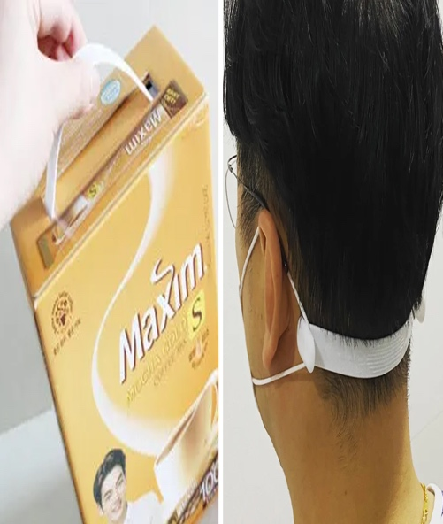
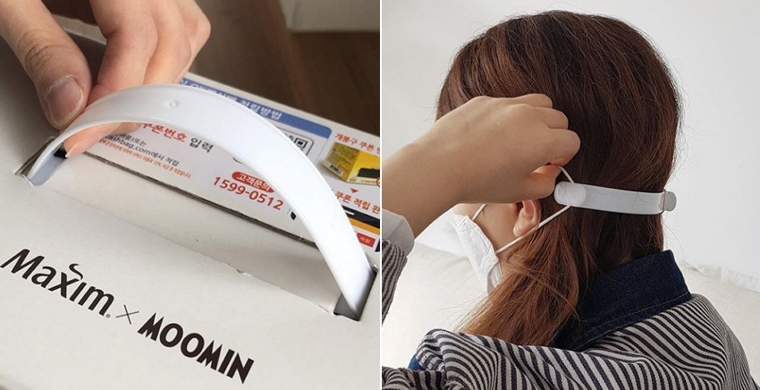
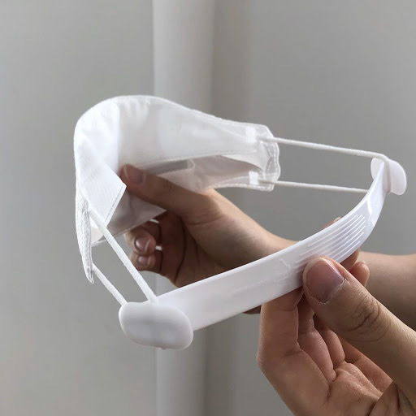
If you have any issues with ear pain due to wearing the ear loop masks for prolonged periods of time, check out this neat way of prevention (see internal website resources for more instructions):

If you need a tighter fit of your ear loop mask or for another way to further reduce discomfort behind the ears, see this tip on wrapping around a ponytail (if you can). One caution is that this can stretch the straps more than usual, so for longterm use, the straps may wear out more quickly. Always inspect your mask to make sure it is not worn out.
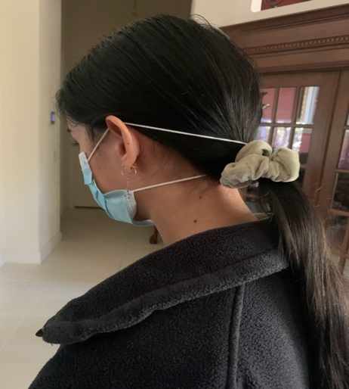
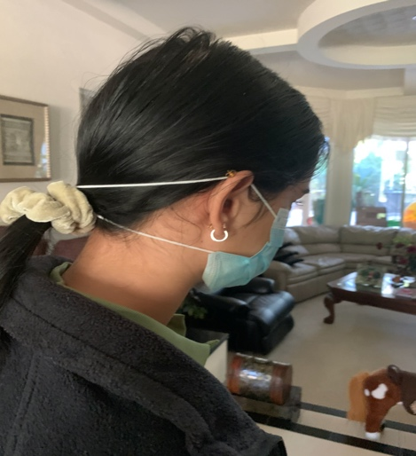

When transitioning from work to home:
- You can hang up your surgical mask and change to your home-made mask as shown.
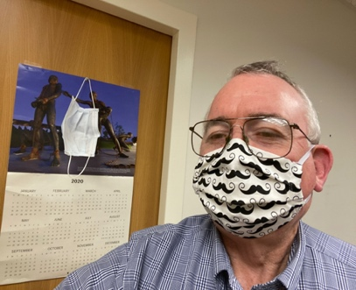
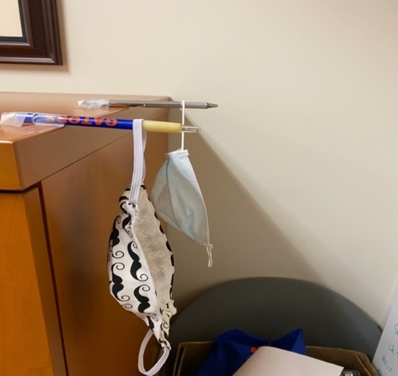

To clean your homemade mask, watch this video.

For Contact precautions:
To properly Gown and Glove, watch video available on the GME website.
Please ensure you are fit tested to figure out your size. If fit test failed, you need to wear CAPR when possible or avoid/not participate in any aerosol generating procedures.

Donning/Doffing a New N-95 Mask and Surgical Mask
N95 masks can be used multiple times with different patients as long as paired with a surgical mask. If working in high-risk areas like the ED, you can wear your N95 continuously throughout your shift.

Watch this video (from CDC; recommend second sequence in the video) for full instructions on how to don/doff full PPE. Here is a another video for another example (watch CDC video first).

The N95 mask should be inspected after every use and discarded if damaged and or has visible soiling.
- Wash your hands.
- Don the gown and gloves first as noted above.
- Then don your fit-tested N95 mask:
- Cup the N95 in one hand and press it against the face, over the nose and mouth.
- Pinch the nose clip into place thus ensuring a tight seal.
- With the hand on N95 still in place use the other hand to pull the top strap over your head followed by lower strap.

Surgical Masks to cover the N95 (if going to re-use the N95):
- Surgical Masks with ear loops: Stretch the surgical mask completely over the N95 mask, place loops over both ears and then pinch the nose of surgical mask.
  - If surgical mask with strings—first tie the top straps behind the back of the head then pull the surgical mask completely over the N95 and then proceed to tie the bottom straps behind the head.
- Use care not to touch the front of the mask at any time after donning. Handle only by the strings.
- Once done, remove gown and gloves inside the patient room, wash hands immediately.
- Then step out of the patient room, put on new gloves and without touching the front of the surgical mask remove the mask by lopes or ties from behind and dispose in designated bin.
- If accidentally touched the front of the mask, stop. Remove the gloves, re-wash hands, don new gloves and remove in the manner mentioned above.
- Now carefully remove the N95 mask from face. Make sure to touch only the strap and the extreme edges.
- Remove the bottom strap first followed by top while leaning forward so the N95 lands into your gloved hand.
- Then inspect mask.
- If contaminated, discard. If not, place in a paper bag or open plastic bag that is labeled. Then proceed to remove the gloves and perform hand washing again.

DISPOSAL/DISINFECTION of Surgical Masks and N95s
- Per protocol, each mask should be marked with the staff members First and Last Name or initials and what unit.
- Each N95 mask should be disinfected after 24 hours of usage time (Two 12 hour shifts or three 8 hour shifts)
- Any obviously contaminated and/or damaged masks are to be discarded.
- After safely removing the masks, place the masks into individual paper bags or plastic bags and place them in grey bins located in the soiled utility room.
- S/P disinfection process by UV light, the masks are marked with X and placed in new bags with name of the owner written on it. After 4 disinfection cycles the masks are automatically discarded.

When using goggles:
- Donning/Doffing a surgical mask (earloop), gown, gloves, and goggles (including disinfection of goggles)
  - Video with CDC sequencing

Clothing
- Wear easily washable clothing. Avoid clothing that requires dry-cleaning (as many drycleaners are closed). Personal scrubs are acceptable in all clinical areas during the COVID-19 pandemic. The department will supply some scrubs to those individuals working in higher risk areas such as the ED and Unit 52; please see Holly in MOB1/AOPC. There are ongoing efforts to provide more scrubs.
- To minimize dispersing virus through the air, please do not shake dirty laundry.
- Try to change in home garage or other isolated area.
- Separate work clothing from other household laundry. Do not allow household contacts to launder clothing. Wash hands thoroughly after handling work clothing. Wash clothing with highest possible temperature. Dry well.
- Clean and disinfect hampers or other carts for transporting laundry according to the type of surface (Hard/Non-Porous, Soft/Porous)
- If Hard/Non-Porous surface—when dirty, clean with detergent or soap and water prior to disinfection. Disinfection should be done by following the manufactures instructions.
- If Soft/Porous such as carpets, rugs, drapes remove visible contamination and clean with appropriate manufacturer-indicated cleaners. And if they can be washed please use the warmest water possible. Ensure fully dry after.
- Recommend having work shoes that are only used at work site. Consider leaving work shoes in trunk of car (inside paper bag) as long as others will not access. Change shoes before and after work. Use personal hand sanitizer after changing shoes.
- Shower immediately upon returning home from work.
- Be sure to clean/disinfect your phone, watch, and other personal items with soap/water or an alcohol-based sanitizer (depending on the material; see manufacturer’s instructions).

How to Clean Your Phone and Smartwatch
Note: Always check your specific product manufacturer specifications. Consider spot cleaning in a small area first.

How to clean your Apple products (can be applied to Androids as well).
https://support.apple.com/en-us/HT204172?mod=article_inline
Apple products are made with a variety of materials, and each material might have specific cleaning requirements. To get started, here are some tips that apply to all products:
- Use only a soft, lint-free cloth. Avoid abrasive cloths, towels, paper towels, or similar items.
- Avoid excessive wiping, which might cause damage.
- Unplug all external power sources, devices, and cables.
- Keep liquids away from the product, unless otherwise noted for specific products.
- Don't get moisture into any openings.
- Don't use aerosol sprays, bleaches, or abrasives.
- Don't spray cleaners directly onto the item.
Is it OK to use a disinfectant on my Apple product?
Using a 70 percent isopropyl alcohol wipe or Clorox Disinfecting Wipe, gently wipe the hard, nonporous surfaces of your Apple product, such as the display, keyboard, or other exterior surfaces. Don't use bleach. Avoid getting moisture in any opening, and don't submerge your Apple product in any cleaning agents. Don't use on fabric or leather surfaces.

Protection at Home (see Appendix for more info)
- Household checklist from the CDC
- Choose a room in your house that can be used to separate sick household members from others.
- Use the separate room and bathroom you prepared for sick household members (if possible).
- Learn how to care for someone with COVID-19 at home.
- Avoid sharing personal items like food and drinks.
- Provide your sick household member with clean disposable facemasks to wear at home, if available, to help prevent spreading COVID-19 to others.
- Clean the sick room and bathroom, as needed, to avoid unnecessary contact with the sick person.

Protecting Your Food
- Watch this video to help you learn how to clean your food/groceries.
- Better yet, use a pick-up or delivery service for your groceries. Example

Other Advice: Current as of 5/08/2020

Travel
- Avoid all travel. Stay at home except for necessary errands (e.g. grocery shopping).

APPENDIX: Further detailed information to supplement above:

The UF HEALTH BRIDGE is a source of important information on COVID-19:

- To Access information, log onto the UF health Bridge
- On the first tab, roll mouse onto Collaborations and the menu pops up. On the first category which has people and groups, click on UF HEALTH SHARE POINT which should take you to another site which will have COVID 19 Resources
- The tab with information about protocols in place is the patient care clinical guidance.

Coronavirus/COVID-19/SARS-CoV-2 (Reference) (Reference)
Clinical Presentation
- Non-specific, flu like illness with myalgia’s. May have fevers, cough, SOB, Upper respiratory symptoms/nasal or sinus congestion, +/-Anosmia (loss of smell), and +/- GI symptoms.
- Just like with SARS and MERs – COVID-19 spreads from person to person with most of it happening among close contact—within about 6 feet distance.
- This type of transmission occurs via respiratory droplets, fomites (But COVID-19 transmission to persons from contaminated surfaces has not been clearly documented yet. And possibly via infectious aerosols. COVID-19 may remain viable for hours to days on surfaces made from a variety of material - Viral particles survive < 24h on cardboard, < 72h on plastic or steel; Aerosols (droplet nuclei, < 5 µm), estimated < 4h
- Incubation period: median 4 days, common range 2-7 days, up to 24 days. Symptomatic and asymptomatic patients can transmit the virus.
- Disease course: Most (around 80%) do not require critical care, some develop bacterial superinfection, and some have respiratory viral infection, ARDS, Cardiomyopathy. If hypoxemic respiratory failure – ICU care required.
- Prognosis- Still ongoing-But high risk- if males >65 years of age, with co-morbidities such as Cardiovascular disease, Pulmonary diseases, Malignancy, Diabetes, IC. But remember Mortality rate correlates with age and availability of medical resources.

How to Protect yourself:
- Know how it spreads:
COVID-19 is thought to spread mainly through close contact from person-to-person (Usually within 6 ft) in respiratory droplets produced when an infected person coughs, sneezes or talks. These droplets can land in the mouths or noses of people who are nearby or possibly be inhaled into the lungs. Some recent studies have suggested that COVID-19 may be spread by people who are not showing symptoms.

- Everyone should:
Clean your hands often
Wash your hands often with soap and water for at least 20 seconds. Especially if you recently have been in a public place, or after blowing your nose, coughing, or sneezing.
- If soap and water are not readily available, use a hand sanitizer that contains at least 60% alcohol. Cover all surfaces of your hands and rub them together until they feel dry.
- Avoid touching your eyes, nose, and mouth with unwashed hands.
Avoid close contact
- Avoid close contact with people who are sick
- Stay home as much as possible
- Put distance between yourself and other people.
- Remember that some people without symptoms may be able to spread virus
- Keeping distance from others is especially important for people who are at higher risk of getting very sick.
Stay home if you’re sick
- Stay home if you are sick, except to get medical care (call your doctor first).
Cover coughs and sneezes
- Cover your mouth and nose with a tissue when you cough or sneeze or use the inside of your elbow.
- Throw used tissues in the trash.
- Immediately wash your hands with soap and water for at least 20 seconds. If soap and water are not readily available, clean your hands with a hand sanitizer that contains at least 60% alcohol.
Wear a facemask if you are sick
- If you are sick: You should wear a facemask when you are around other people (e.g., sharing a room or vehicle) and before you enter a healthcare provider’s office. If you are not able to wear a facemask (for example, because it causes trouble breathing), then you should do your best to cover your coughs and sneezes, and people who are caring for you should wear a facemask if they enter your room.
- If you are NOT sick: You do not need to wear a facemask unless you are caring for someone who is sick (and they are not able to wear a facemask). Facemasks may be in short supply and they should be saved for caregivers.
Clean and disinfect
- Clean AND disinfect frequently touched surfaces daily. This includes tables, doorknobs, light switches, countertops, handles, desks, phones, keyboards, toilets, faucets, and sinks.
- If surfaces are dirty, clean them: Use detergent or soap and water prior to disinfection.
To disinfect:
Most common EPA-registered household disinfectants will work. Use disinfectants appropriate for the surface.
Options include:
- Diluting your household bleach.
To make a bleach solution, mix:
  - 5 tablespoons (1/3rd cup) bleach per gallon of water
OR
  - 4 teaspoons bleach per quart of water
  - NOTE: Diluted bleach solutions are only effective for 24 hours and must be re-made each day.
Follow manufacturer’s instructions for application and proper ventilation. Check to ensure the product is not past its expiration date. Never mix household bleach with ammonia or any other cleanser. Unexpired household bleach will be effective against coronaviruses when properly diluted.
- Alcohol solutions.
Ensure solution has at least 70% alcohol.
- Other common EPA-registered household disinfectants.
Products with EPA-approved emerging viral pathogens claims are expected to be effective against COVID-19 based on data for harder to kill viruses. Follow the manufacturer’s instructions for all cleaning and disinfection products (e.g., concentration, application method and contact time, etc.).

More information on masks: surgical, N95, KN95
https://blogs.cdc.gov/niosh-science-blog/2009/10/14/n95/
This is from the CDC – it takes you NIOSHA where it talks about N95 and surgical masks and the differences.

https://www.nytimes.com/2020/04/03/health/coronavirus-n95-kn95-masks.html
The CDC Lists KN95 masks as a suitable alternative when N95s are not available on Friday 4/3/20. The FDA issued an emergency use authorization for KN95 masks. The KN95s are regulated by the Chinese government, almost identical in performance to N95 masks but different in specifications (such as variations in the maximum pressure the mask can withstand as the person inhales and exhales). They are also manufactured under slightly different regulatory and testing standards as well. (https://multimedia.3m.com/mws/media/1791500O/comparison-ffp2-kn95-n95-filtering-facepiece-respirator-classes-tb.pdf)
(https://www.forbes.com/sites/rachelsandler/2020/04/03/fda-reverses-course-approves-chinas-equivalent-of-the-n95-mask-to-protect-against-coronavirus/#3cda71b916cb)

https://www.ncbi.nlm.nih.gov/pmc/articles/PMC5058571/
Respiratory protective devices (RPDs) have been usually used to protect people from respiratory hazards such as any biological, chemical and or radioactive materials.

Part of the RPDs are the Disposable filtering half-face piece respirators (DFHFRs), which are classified as air-purifying respirators which come in multiple sizes to fit a wide variety of face ranges. And amongst these DFHFRs are, NIOSH approved and recommends N95 filtering face piece respirators or higher for healthcare workers against airborne infectious.
The US National Institute for Occupational Safety and Health (NIOSH) classifies particulate filtering face piece respirators (FFRs) into nine categories (N95, N99, N100, P95, P99, P100, R95, R99, and R100).
N (not resistant to oil) means that the respirators cannot be used in an oil droplet environment;
R (somewhat resistant to oil)
P (strongly resistant to oil) mean that this respirator can be used for protection against non-oily and oily aerosols.
While Numerical designations 95, 99, and 100 show the filter's minimum filtration efficiency with 95%, 99%, and 99.97%, respectively.
The European Standard (EN 149:2001) classifies FFRs into three classes: FFP1, FFP2, and FFP3 with corresponding minimum filtration efficiencies of 80%, 94%, and 99%. Therefore, FFP2 respirators are approximately equivalent to N95 FFRs, making them recommended for use in the prevention of airborne infectious diseases in the US and some other countries.
While the Chinese standard in KN95.
Surgical masks (SMs) are used to block large particles (such as droplets, splashes, sprays, or splatter) that may contain microorganisms (e.g., viruses and bacteria) from reaching the nose and mouth. And although they are primarily intended to protect patients from healthcare workers by minimizing exposure of saliva and respiratory secretions to the patients, they generally do not form a tight seal against the face skin and so are not recommended to protect people from airborne infectious diseases.
The protection provided by SMs against particles (0.04–1.3 μm) is 8–12 times less than N95 FFRs. SMs have been cleared by the Food and Drug Administration for sale in the US.
In summary, N95, KN95 and KF94, FFP2 are all respiratory protective devices. They all Stop 95% of particles >0.3 Microns in size. The difference is that N95 is the USA Code, KN95 is China code, KF94 is Korea code and FFP2 is the EU code, this includes the UK (https://www.cdc.gov/niosh/npptl/pdfs/UnderstandDifferenceInfographic-508.pdf)

TRAINING VIDEOS
*Collected from text above
- UF Health Handwashing, Donning/Doffing Mask/Cleaning
  - YouTube channel
- Handwashing
  - UFPsychHWTutorial
  - UFPsychGGVideo (Glow Germ test)
- Donning/Doffing a surgical mask (earloop)
  - UFPsychMaskTutorial
  - video
- Donning/Doffing a surgical mask (tie)
  - SurgicalMaskTyingVideo
- Donning/Doffing a surgical mask (earloop), gown, gloves, and goggles (including disinfection of goggles)
  - Video with CDC sequencing
- Gowning and gloving
  - video
- Donning/Doffing full PPE (with N95):
  - CDC sequence (recommend second sequence)
    - video
  - Another example
    - video
- Donning/Doffing N95 with eye protection
  - CAPR (YouTube: Donning, Doffing)
  - PAPR (YouTube: Donning, Doffing)
  - N95 with eye protection (YouTube: Donning, Doffing)
- Cleaning your homemade mask
  - video
- Protecting your food
  - video

The Mindful Gator Quick Infection Control Tips

Infection Control: The Basics for Our Next New “Normal” (The Artist Formerly Known as The Long Plateau of the Curve)

Do NOT come to work sick! If you see someone else who looks sick, please ask them to go home and make sure the supervisor is aware.

Handwashing: Wash your hands frequently with soap and water for at least 20 seconds each time. Use an alcohol-based hand sanitizer otherwise.

Social Distancing: Maintain 6+ feet of distance between you and others. Do not congregate in small/confined areas. Remove furniture that cannot be easily cleaned/disinfected (e.g. cloth chairs). Turn over or otherwise remove any chairs/tables that promote congregation. Where chairs are required, place at least 6 feet apart and monitor frequently for any movement of such items closer together.

Clothing: Wear easily washable clothing. Scrubs are permissible at this time. Change your clothes immediately upon returning home (preferably in a segregated area),

Mask: For routine clinical care in the inpatient and outpatient settings, wear an earloop surgical mask continuously when in patient care areas. In high-risk areas such as the ED or as directed by your supervisor or signage, wear a properly fitted N95 mask.

Cleaning: Areas should be frequently cleaned by housekeeping and clinical staff as well as by each of us individually. We should wipe down our work areas at the beginning and end of the day at a minimum. See your area manager for cleaning supplies. Feel free to bring your own from home as well.

Be a Spotter: Watch out for others in your area (including staff) and coach them on good infection control. Consider adopting an accountability partner or buddy to keep you on track.

Signage: Please put up signs (as allowed) in your area to promote social distancing (e.g. put a 6-foot painter’s tape on wall), handwashing, wearing masks/face coverings, and cleaning habits.

Do NOT become complacent or have a false sense of security! Follow the above at all times.

The Mindful Gator Infection Control Basic Skill Checklist
Infection Control Basic Skill Checklist:

Personal Health
- Monitors self for signs/symptoms of COVID-19 (e.g. fever, cough, shortness of breath, chills, body aches, headache, sore throat, new loss of taste or smell)
- Contacts supervisor if sick and does not come to work
Handwashing
- Washes hands with soap and water for at least 20 seconds or uses an alcohol-based hand sanitizer, making sure to wash all surfaces including between fingers, under rings, back of hands
- Washes hands after removing mask, gloves, and other personal protective equipment (PPE)
- Glow light testing completed (when available)
Social/Physical Distancing
- Maintains 6+ feet of distance between self and others
- Does not congregate in small/confined areas
Clothing
- Wears easily washable clothing (e.g. scrubs)
- Changes clothing immediately upon returning home (preferably in a segregated area) and showers before interacting with other members of household
- Regularly cleans/disinfects phone, watch, and other work/personal items
Mask
- Wears a surgical mask continuously when in patient care areas AND when working with other staff
- Refrains from touching or pulling on mask throughout day
- Refrains from touching face
- Does not pull mask down, exposing nose/mouth
- Does not wear mask around neck
- Only removes mask by the loops/strings
- Wears N95 and other appropriate PPE in high-risk areas such as the ED or as directed by supervisor or signage
- Wears a properly fitted N95 mask, if applicable
Cleaning
- Wipes down work area with disinfectant at the beginning and end of the day at a minimum (or as appropriate for area)
Spotter
- Watches out for others in work area for above and coaches them on good infection control (IC) techniques.
- Has 1 or more accountability partner/buddy to assist in maintaining IC skills

