Infection Control Task Force (of COVID-19 MH Consortium)
Includes Mask Task Force and Infection Control Procedures Work Group

Members: Jacqueline A. Hobbs, MD, PhD (Chair); Elizabeth Ahn, MD; Lara Dowling; Roxane Harcourt, LCSW, LMFT; Ryan Joy, MD; Nicholas Martinez, MD; Meena Nuthi, MD; Priscilla Spence; John Repique, DNP, RN; Joe Thornton, MD
Table of Contents (Click on items to go directly to section)
Top Things to Do to Protect Yourself and Your Patients in the Hospital and at Home 1
Best Practices for Inpatient Psychiatric Care During COVID-19 Pandemic 2
PPE 2
Clothing 6
How to Clean Your Phone and Smartwatch 7
Protection at Home (see Appendix for more info) 7
Protecting Your Food 8
Travel 8
APPENDIX: Further detailed information to supplement above: 9
TRAINING VIDEOS 12
The Mindful Gator Quick Infection Control Tips 13
The Mindful Gator Infection Control Basic Skill Checklist 14

Top Things to Do to Protect Yourself and Your Patients in the Hospital and at Home
- Prior to interacting with a patient, please do a thorough chart review to see if any contact/airborne precautions? If so reach out to RD/attending/service chief for further instructions. Once at the room, please look for precaution signs and don appropriate PPE gear. When leaving, please remove the gear using sterile technique and wash hands with soap and water.
- Frequently wash your hands for 20 seconds (sing “Happy Birthday” song twice) with soap and water. If soap and water are not available and your hands are not overtly dirty then use alcohol-based hand sanitizers that contain at least 60% alcohol. Dry hands thoroughly and use the paper towel to turn off the faucet. You can check your technique using Glow Germ (https://www.glogerm.com).
- After washing your hands, please continue to avoid touching your eyes, nose, mouth and your face.
- Do not come to work if sick. Check with your supervisor if you have questions.
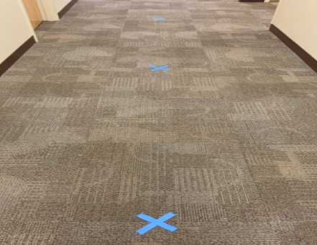
- Put surgical mask on patients with symptoms. This is the greatest way to reduce your/other risk. Do not put N95 masks on symptomatic patients.
- Practice social/physical distancing—keep at least 6 feet of distance between you and others (see picture).
- Wear a mask (see below).

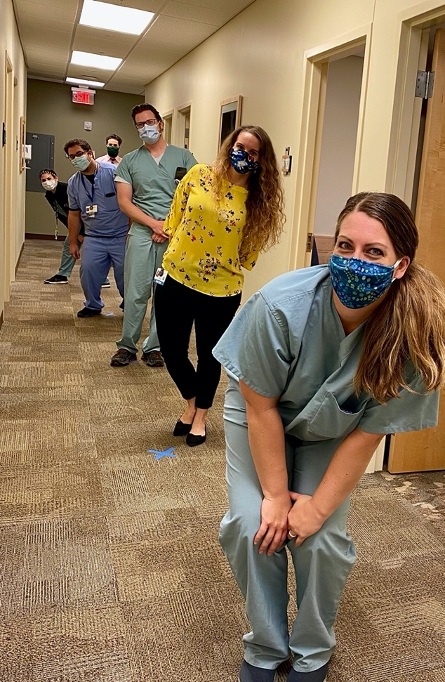

Best Practices for Inpatient Psychiatric Care During COVID-19 Pandemic
http://alert.psychnews.org/2020/04/five-strategies-to-protect-patients.html

PPE
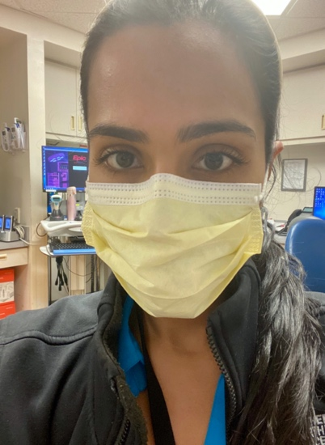
It is important to keep in mind that wearing earloop-style and/or N95-type masks does not replace the need to (1) practice frequent hand hygiene, (2) keep a 6-foot distance from others as much as feasible, and to (3) stay home if you develop a fever or any type of acute illness. When caring for a patient on airborne or modified airborne isolation, only an N95 mask or CAPR should be used. Please be aware that N95s and CAPRs are very limited resources and should not be worn for routine use.

A note on home-made masks. Home-made masks are allowed per The Joint Commission. If you do use a home-made mask, please follow the same good practices for donning and doffing your mask and washing your hands as discussed below.

Proper PPE depends on your clinical location and whether there are contact or other precautions in place for a particular patient.

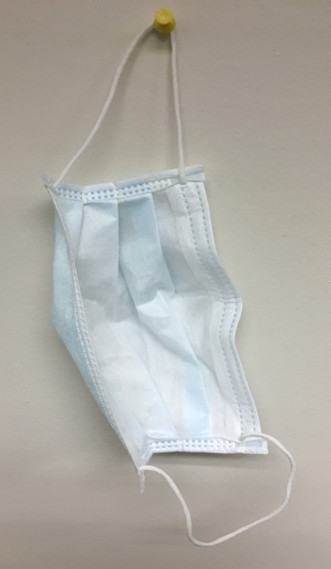
For most routine clinical care in the outpatient setting or general wards (where no precautions are in place), use a surgical ear loop mask continuously throughout the day. (Reference). If slippage of the mask off the nose tends to occur, consider whether your mask is too worn for continued use. Consider exchanging for a new mask. Another option is to use medical-grade tape across the bridge of the nose and the mask to help keep the mask in place. One more alternative is to use a surgical tie mask (see this SurgicalMaskTyingVideo for instructions and great illustration of the safety features of surgical masks).
Here’s a great reference for an alternative tying method to reduce glass fogging. When using masks with ties, the standard way of tying a surgical mask involves tying the two ties so they lie above and below the ear, almost in a near parallel appearance. But this sometimes causes fogging of eye wear. To reduce, if not prevent, the fogging of glasses, knotting of the superior tie first with it lying directly below the ear while the inferior tie is brought up in front of the ear and knotted over the crown of the head. This forms two lateral vents naturally. For pictures please click on the reference above.

- Watch this video on how to properly don and doff (remove) a surgical earloop mask. Make sure the colored side faces outward.
- Refrain from touching your face or the outside of the mask. If you do touch the mask, wash your hands as noted above.
- You may have to wear the same mask for one or more days depending on your hospital’s supplies. If you must wear longer than 1 day, remove the mask carefully as noted in the video and hang up your mask on a hook near your desk/work area with outside nearest to wall or other surface. Write your name with a Sharpie on the inside corner.
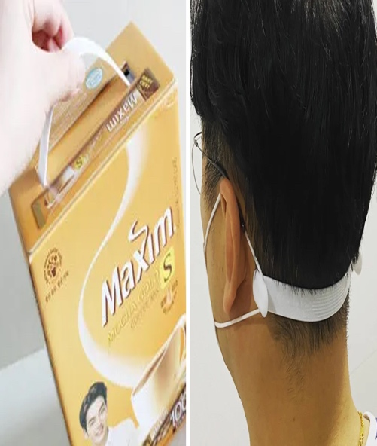
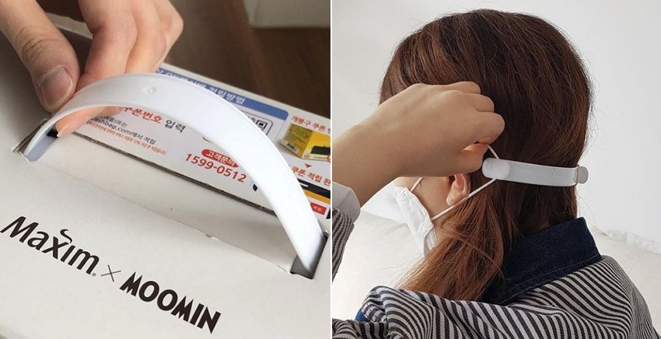
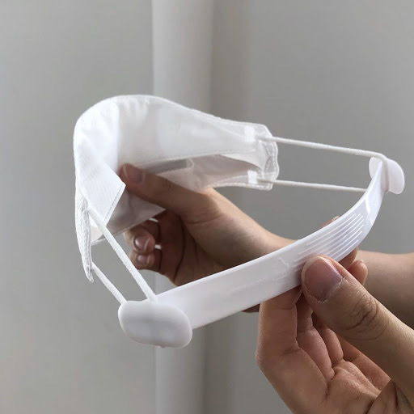
If you have any issues with ear pain due to wearing the ear loop masks for prolonged periods of time, check out this neat way of prevention:

If you need a tighter fit of your ear loop mask or for another way to further reduce discomfort behind the ears, see this tip on wrapping around a ponytail (if you can). One caution is that this can stretch the straps more than usual, so for longterm use, the straps may wear out more quickly. Always inspect your mask to make sure it is not worn out.
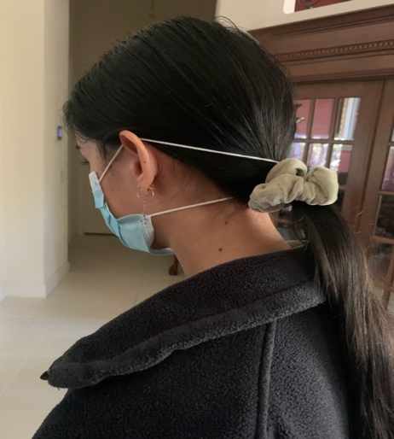
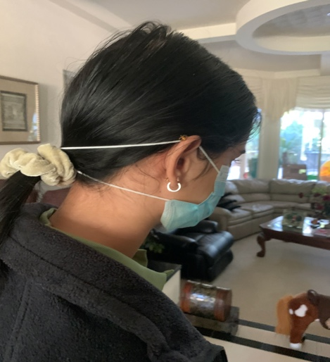

When transitioning from work to home:
- You can hang up your surgical mask and change to your home-made mask as shown.
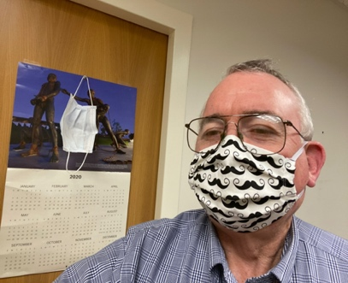
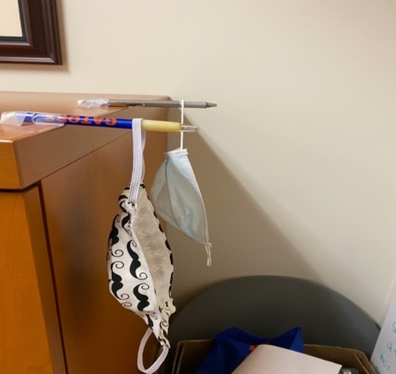

To clean your homemade mask, watch this video.

When precautions are in place:
Please ensure you are N95 fit tested to figure out your size. If fit test failed, you need to wear CAPR when possible or avoid/not participate in any aerosol generating procedures.

Donning/Doffing a New N-95 Mask and Surgical Mask
N95 masks can be used multiple times with different patients as long as paired with a surgical mask. If working in high-risk areas like the ED, you can wear your N95 continuously throughout your shift.

Watch this video (from CDC; recommend second sequence in the video) for full instructions on how to don/doff full PPE. Here is a another video for another example (watch CDC video first).

The N95 mask should be inspected after every use and discarded if damaged and or has visible soiling.
- Wash your hands.
- Don the gown and gloves first as noted above.
- Then don your fit-tested N95 mask:
- Cup the N95 in one hand and press it against the face, over the nose and mouth.
- Pinch the nose clip into place thus ensuring a tight seal.
- With the hand on N95 still in place use the other hand to pull the top strap over your head followed by lower strap.

Surgical Masks to cover the N95 (if going to re-use the N95):
- Surgical Masks with ear loops: Stretch the surgical mask completely over the N95 mask, place loops over both ears and then pinch the nose of surgical mask.
  - If surgical mask with strings—first tie the top straps behind the back of the head then pull the surgical mask completely over the N95 and then proceed to tie the bottom straps behind the head.
- Use care not to touch the front of the mask at any time after donning. Handle only by the strings.
- Once done, remove gown and gloves inside the patient room, wash hands immediately.
- Then step out of the patient room, put on new gloves and without touching the front of the surgical mask remove the mask by lopes or ties from behind and dispose in designated bin.
- If accidentally touched the front of the mask, stop. Remove the gloves, re-wash hands, don new gloves and remove in the manner mentioned above.
- Now carefully remove the N95 mask from face. Make sure to touch only the strap and the extreme edges.
- Remove the bottom strap first followed by top while leaning forward so the N95 lands into your gloved hand.
- Then inspect mask.
- If contaminated, discard. If not, place in a paper bag or open plastic bag that is labeled. Then proceed to remove the gloves and perform hand washing again.

DISPOSAL/DISINFECTION of Surgical Masks and N95s
- Per protocol, each mask should be marked with the staff members First and Last Name or initials and what unit.
- Each N95 mask should be disinfected after 24 hours of usage time (Two 12 hour shifts or three 8 hour shifts)
- Any obviously contaminated and/or damaged masks are to be discarded.
- After safely removing the masks, place the masks into individual paper bags or plastic bags and place them in grey bins located in the soiled utility room.
- S/P disinfection process by UV light, the masks are marked with X and placed in new bags with name of the owner written on it. After 4 disinfection cycles the masks are automatically discarded.

When using goggles:
- Donning/Doffing a surgical mask (earloop), gown, gloves, and goggles (including disinfection of goggles)
  - Video with CDC sequencing

Clothing
- Wear easily washable clothing. Avoid clothing that requires dry-cleaning (as many drycleaners are closed). Personal scrubs are acceptable in all clinical areas during the COVID-19 pandemic.
- To minimize dispersing virus through the air, please do not shake dirty laundry.
- Try to change in home garage or other isolated area.
- Separate work clothing from other household laundry. Do not allow household contacts to launder clothing. Wash hands thoroughly after handling work clothing. Wash clothing with highest possible temperature. Dry well.
- Clean and disinfect hampers or other carts for transporting laundry according to the type of surface (Hard/Non-Porous, Soft/Porous)
- If Hard/Non-Porous surface—when dirty, clean with detergent or soap and water prior to disinfection. Disinfection should be done by following the manufactures instructions.
- If Soft/Porous such as carpets, rugs, drapes remove visible contamination and clean with appropriate manufacturer-indicated cleaners. And if they can be washed please use the warmest water possible. Ensure fully dry after.
- Recommend having work shoes that are only used at work site. Consider leaving work shoes in trunk of car (inside paper bag) as long as others will not access. Change shoes before and after work. Use personal hand sanitizer after changing shoes.
- Shower immediately upon returning home from work.
- Be sure to clean/disinfect your phone, watch, and other personal items with soap/water or an alcohol-based sanitizer (depending on the material; see manufacturer’s instructions and below).

How to Clean Your Phone and Smartwatch
Note: Always check your specific product manufacturer specifications. Consider spot cleaning in a small area first.

How to clean your Apple products (can be applied to Androids as well).
https://support.apple.com/en-us/HT204172?mod=article_inline
Apple products are made with a variety of materials, and each material might have specific cleaning requirements. To get started, here are some tips that apply to all products:
- Use only a soft, lint-free cloth. Avoid abrasive cloths, towels, paper towels, or similar items.
- Avoid excessive wiping, which might cause damage.
- Unplug all external power sources, devices, and cables.
- Keep liquids away from the product, unless otherwise noted for specific products.
- Don't get moisture into any openings.
- Don't use aerosol sprays, bleaches, or abrasives.
- Don't spray cleaners directly onto the item.
Is it OK to use a disinfectant on my Apple product?
Using a 70 percent isopropyl alcohol wipe or Clorox Disinfecting Wipe, gently wipe the hard, nonporous surfaces of your Apple product, such as the display, keyboard, or other exterior surfaces. Don't use bleach. Avoid getting moisture in any opening, and don't submerge your Apple product in any cleaning agents. Don't use on fabric or leather surfaces.

Protection at Home (see Appendix for more info)
- Household checklist from the CDC
- Choose a room in your house that can be used to separate sick household members from others.
- Use the separate room and bathroom you prepared for sick household members (if possible).
- Learn how to care for someone with COVID-19 at home.
- Avoid sharing personal items like food and drinks.
- Provide your sick household member with clean disposable facemasks to wear at home, if available, to help prevent spreading COVID-19 to others.
- Clean the sick room and bathroom, as needed, to avoid unnecessary contact with the sick person.

Protecting Your Food
- Watch this video to help you learn how to clean your food/groceries.
- Better yet, use a pick-up or delivery service for your groceries. Example

Other Advice: Current as of 4/22/20

Travel
- Avoid all travel. Stay at home except for necessary errands (e.g. grocery shopping).

APPENDIX: Further detailed information to supplement above:

Coronavirus/COVID-19/SARS-CoV-2 (Reference) (Reference)
Clinical Presentation
- Non-specific, flu like illness with myalgia’s. May have fevers, cough, SOB, Upper respiratory symptoms/nasal or sinus congestion, +/-Anosmia (loss of smell), and +/- GI symptoms.
- Just like with SARS and MERs – COVID-19 spreads from person to person with most of it happening among close contact—within about 6 feet distance.
- This type of transmission occurs via respiratory droplets, fomites (But COVID-19 transmission to persons from contaminated surfaces has not been clearly documented yet. And possibly via infectious aerosols. COVID-19 may remain viable for hours to days on surfaces made from a variety of material - Viral particles survive < 24h on cardboard, < 72h on plastic or steel; Aerosols (droplet nuclei, < 5 µm), estimated < 4h
- Incubation period: median 4 days, common range 2-7 days, up to 24 days. Symptomatic and asymptomatic patients can transmit the virus.
- Disease course: Most (around 80%) do not require critical care, some develop bacterial superinfection, and some have respiratory viral infection, ARDS, Cardiomyopathy. If hypoxemic respiratory failure – ICU care required.
- Prognosis- Still ongoing-But high risk- if males >65 years of age, with co-morbidities such as Cardiovascular disease, Pulmonary diseases, Malignancy, Diabetes, IC. But remember Mortality rate correlates with age and availability of medical resources.

How to Protect yourself:
- Know how it spreads:
COVID-19 is thought to spread mainly through close contact from person-to-person (Usually within 6 ft) in respiratory droplets produced when an infected person coughs, sneezes or talks. These droplets can land in the mouths or noses of people who are nearby or possibly be inhaled into the lungs. Some recent studies have suggested that COVID-19 may be spread by people who are not showing symptoms.

- Everyone should:
Clean your hands often
Wash your hands often with soap and water for at least 20 seconds. Especially if you recently have been in a public place, or after blowing your nose, coughing, or sneezing.
- If soap and water are not readily available, use a hand sanitizer that contains at least 60% alcohol. Cover all surfaces of your hands and rub them together until they feel dry.
- Avoid touching your eyes, nose, and mouth with unwashed hands.
Avoid close contact
- Avoid close contact with people who are sick
- Stay home as much as possible
- Put distance between yourself and other people.
- Remember that some people without symptoms may be able to spread virus
- Keeping distance from others is especially important for people who are at higher risk of getting very sick.
Stay home if you’re sick
- Stay home if you are sick, except to get medical care (call your doctor first).
Cover coughs and sneezes
- Cover your mouth and nose with a tissue when you cough or sneeze or use the inside of your elbow.
- Throw used tissues in the trash.
- Immediately wash your hands with soap and water for at least 20 seconds. If soap and water are not readily available, clean your hands with a hand sanitizer that contains at least 60% alcohol.
Wear a facemask if you are sick
- If you are sick: You should wear a facemask when you are around other people (e.g., sharing a room or vehicle) and before you enter a healthcare provider’s office. If you are not able to wear a facemask (for example, because it causes trouble breathing), then you should do your best to cover your coughs and sneezes, and people who are caring for you should wear a facemask if they enter your room.
- If you are NOT sick: You do not need to wear a facemask unless you are caring for someone who is sick (and they are not able to wear a facemask). Facemasks may be in short supply and they should be saved for caregivers.
Clean and disinfect
- Clean AND disinfect frequently touched surfaces daily. This includes tables, doorknobs, light switches, countertops, handles, desks, phones, keyboards, toilets, faucets, and sinks.
- If surfaces are dirty, clean them: Use detergent or soap and water prior to disinfection.
To disinfect:
Most common EPA-registered household disinfectants will work. Use disinfectants appropriate for the surface.
Options include:
- Diluting your household bleach.
To make a bleach solution, mix:
  - 5 tablespoons (1/3rd cup) bleach per gallon of water
OR
  - 4 teaspoons bleach per quart of water
  - NOTE: Diluted bleach solutions are only effective for 24 hours and must be re-made each day.
Follow manufacturer’s instructions for application and proper ventilation. Check to ensure the product is not past its expiration date. Never mix household bleach with ammonia or any other cleanser. Unexpired household bleach will be effective against coronaviruses when properly diluted.
- Alcohol solutions.
Ensure solution has at least 70% alcohol.
- Other common EPA-registered household disinfectants.
Products with EPA-approved emerging viral pathogens claims are expected to be effective against COVID-19 based on data for harder to kill viruses. Follow the manufacturer’s instructions for all cleaning and disinfection products (e.g., concentration, application method and contact time, etc.).

More information on masks: surgical, N95, KN95
https://blogs.cdc.gov/niosh-science-blog/2009/10/14/n95/
This is from the CDC – it takes you NIOSHA where it talks about N95 and surgical masks and the differences.

https://www.nytimes.com/2020/04/03/health/coronavirus-n95-kn95-masks.html
The CDC Lists KN95 masks as a suitable alternative when N95s are not available on Friday 4/3/20. The FDA issued an emergency use authorization for KN95 masks. The KN95s are regulated by the Chinese government, almost identical in performance to N95 masks but different in specifications (such as variations in the maximum pressure the mask can withstand as the person inhales and exhales). They are also manufactured under slightly different regulatory and testing standards as well. (https://multimedia.3m.com/mws/media/1791500O/comparison-ffp2-kn95-n95-filtering-facepiece-respirator-classes-tb.pdf)
(https://www.forbes.com/sites/rachelsandler/2020/04/03/fda-reverses-course-approves-chinas-equivalent-of-the-n95-mask-to-protect-against-coronavirus/#3cda71b916cb)

https://www.ncbi.nlm.nih.gov/pmc/articles/PMC5058571/
Respiratory protective devices (RPDs) have been usually used to protect people from respiratory hazards such as any biological, chemical and or radioactive materials.

Part of the RPDs are the Disposable filtering half-face piece respirators (DFHFRs), which are classified as air-purifying respirators which come in multiple sizes to fit a wide variety of face ranges. And amongst these DFHFRs are, NIOSH approved and recommends N95 filtering face piece respirators or higher for healthcare workers against airborne infectious.
The US National Institute for Occupational Safety and Health (NIOSH) classifies particulate filtering face piece respirators (FFRs) into nine categories (N95, N99, N100, P95, P99, P100, R95, R99, and R100).
N (not resistant to oil) means that the respirators cannot be used in an oil droplet environment;
R (somewhat resistant to oil)
P (strongly resistant to oil) mean that this respirator can be used for protection against non-oily and oily aerosols.
While Numerical designations 95, 99, and 100 show the filter's minimum filtration efficiency with 95%, 99%, and 99.97%, respectively.
The European Standard (EN 149:2001) classifies FFRs into three classes: FFP1, FFP2, and FFP3 with corresponding minimum filtration efficiencies of 80%, 94%, and 99%. Therefore, FFP2 respirators are approximately equivalent to N95 FFRs, making them recommended for use in the prevention of airborne infectious diseases in the US and some other countries.
While the Chinese standard in KN95.
Surgical masks (SMs) are used to block large particles (such as droplets, splashes, sprays, or splatter) that may contain microorganisms (e.g., viruses and bacteria) from reaching the nose and mouth. And although they are primarily intended to protect patients from healthcare workers by minimizing exposure of saliva and respiratory secretions to the patients, they generally do not form a tight seal against the face skin and so are not recommended to protect people from airborne infectious diseases.
The protection provided by SMs against particles (0.04–1.3 μm) is 8–12 times less than N95 FFRs. SMs have been cleared by the Food and Drug Administration for sale in the US.
In summary, N95, KN95 and KF94, FFP2 are all respiratory protective devices. They all Stop 95% of particles >0.3 Microns in size. The difference is that N95 is the USA Code, KN95 is China code, KF94 is Korea code and FFP2 is the EU code, this includes the UK (https://www.cdc.gov/niosh/npptl/pdfs/UnderstandDifferenceInfographic-508.pdf)

TRAINING VIDEOS
*Collected from text above
- Donning/Doffing a surgical mask (earloop)
  - video
- Donning/Doffing a surgical mask (tie)
  - SurgicalMaskTyingVideo
- Donning/Doffing a surgical mask (earloop), gown, gloves, and goggles (including disinfection of goggles)
  - Video with CDC sequencing
- Donning/Doffing full PPE (with N95):
  - CDC sequence (recommend second sequence)
    - video
  - Another example
    - video
- Donning/Doffing N95 with eye protection
  - CAPR (YouTube: Donning, Doffing)
  - PAPR (YouTube: Donning, Doffing)
  - N95 with eye protection (YouTube: Donning, Doffing)
- Cleaning your homemade mask
  - video
- Protecting your food
  - video

The Mindful Gator Quick Infection Control Tips

Infection Control: The Basics for Our Next New “Normal” (The Artist Formerly Known as The Long Plateau of the Curve)

Do NOT come to work sick! If you see someone else who looks sick, please ask them to go home and make sure the supervisor is aware.

Handwashing: Wash your hands frequently with soap and water for at least 20 seconds each time. Use an alcohol-based hand sanitizer otherwise.

Social Distancing: Maintain 6+ feet of distance between you and others. Do not congregate in small/confined areas. Remove furniture that cannot be easily cleaned/disinfected (e.g. cloth chairs). Turn over or otherwise remove any chairs/tables that promote congregation. Where chairs are required, place at least 6 feet apart and monitor frequently for any movement of such items closer together.

Clothing: Wear easily washable clothing. Scrubs are permissible at this time. Change your clothes immediately upon returning home (preferably in a segregated area),

Mask: For routine clinical care in the inpatient and outpatient settings, wear an earloop surgical mask continuously when in patient care areas. In high-risk areas such as the ED or as directed by your supervisor or signage, wear a properly fitted N95 mask.

Cleaning: Areas should be frequently cleaned by housekeeping and clinical staff as well as by each of us individually. We should wipe down our work areas at the beginning and end of the day at a minimum. See your area manager for cleaning supplies. Feel free to bring your own from home as well.

Be a Spotter: Watch out for others in your area (including staff) and coach them on good infection control. Consider adopting an accountability partner or buddy to keep you on track.

Signage: Please put up signs (as allowed) in your area to promote social distancing (e.g. put a 6-foot painter’s tape on wall), handwashing, wearing masks/face coverings, and cleaning habits.

Do NOT become complacent or have a false sense of security! Follow the above at all times.

The Mindful Gator Infection Control Basic Skill Checklist
Infection Control Basic Skill Checklist:

Personal Health
- Monitors self for signs/symptoms of COVID-19 (e.g. fever, cough, shortness of breath, chills, body aches, HA, sore throat, new loss of taste or smell)
- Contacts supervisor if sick and does not come to work
Handwashing
- Washes hands with soap and water for at least 20 seconds or uses an alcohol-based hand sanitizer, making sure to wash all surfaces including between fingers, under rings, back of hands
- Washes hands after removing mask, gloves, and other personal protective equipment (PPE)
- Glow light testing completed (when available)
Social/Physical Distancing
- Maintains 6+ feet of distance between self and others
- Does not congregate in small/confined areas
Clothing
- Wears easily washable clothing (e.g. scrubs)
- Changes clothing immediately upon returning home (preferably in a segregated area) and showers before interacting with other members of household
- Regularly cleans/disinfects phone, watch, and other work/personal items
Mask
- Wears a surgical mask continuously when in patient care areas AND when working with other staff
- Refrains from touching or pulling on mask throughout day
- Refrains from touching face
- Does not pull mask down, exposing nose/mouth
- Does not wear mask around neck
- Only removes mask by the loops/strings
- Wears N95 and other appropriate PPE in high-risk areas such as the ED or as directed by supervisor or signage
- Wears a properly fitted N95 mask, if applicable
Cleaning
- Wipes down work area at the beginning and end of the day at a minimum (or as appropriate for area)
Spotter
- Watches out for others in work area for above and coaches them on good infection control (IC) techniques.
- Has 1 or more accountability partner/buddy to assist in maintaining IC skills

