SCHEDULE A MEETING
- Open your Zoom client and sign in to Zoom. https://ufl.zoom.us/
- Click on the Schedule icon.
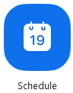
This will open the scheduler window.
- Select your meeting settings. Note that some of these options might not be available if they were disabled and locked to the off position at the account or group level.
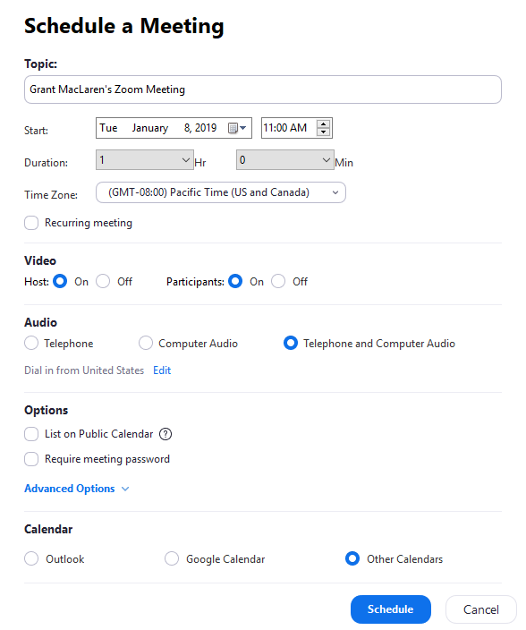
  - Topic: Enter a topic or name for your meeting.
  - Start: Select a date and time for your meeting. You can start your meeting at any time before the scheduled time.
  - Duration: Choose the approximate duration of the meeting. This is only for scheduling purposes. The meeting will not end after this length of time.
  - Time Zone: By default, Zoom will use your computer's time zone. Click the drop-down menu to select a different time zone.
  - Recurring meeting: Choose if you would like a recurring meeting (the meeting ID will remain the same for each session).
  - Video
    - Host: Choose if you would like the host video on or off when joining the meeting. Even if you choose off, the host will have the option to start their video.
    - Participant: Choose if you would like the participants' videos on or off when joining the meeting. Even if you turn off, the participants will have the option to start their video.
  - Audio: Choose whether to allow users to call in via Telephone only, Computer Audio only, Both, or 3rd Party Audio (if enabled for your account).
  - Advanced Options: Click on the arrow to view additional meeting options.
    - Require meeting password: You can select and input your meeting password here. Joining participants will be required to input this before joining your scheduled meeting.
Note: The meeting password must meet these requirements.
      - 10 characters maximum
      - Passwords are case sensitive
      - We recommend using alphanumeric characters and these special characters: @ * _ -
      - The Zoom desktop client allows alphanumeric characters and these special characters: @ * _ -
      - The Zoom web portal allows any characters, but the these characters are not allowed: & <> \
    - Enable join before host: Allow participants to join the meeting without you or before you join. The meeting will end after 40-minutes for Basic (free) users if 3 or more people join the meeting.
    - Mute participants on entry: If join before host is not enabled, this will mute participants as they join the meeting. Participants can unmute themselves after joining the meeting.
Note: To mute all participants currently in a meeting, see the options to manage participants.
    - Use Personal Meeting ID: Check this if you want to use your Personal Meeting ID. If not selected, a random unique meeting ID will be generated.
    - Record the meeting automatically: Check this if you want the meeting to be automatically recorded. Select if you want it to be recorded locally (to your computer) or to the cloud (zoom.us/recording).
    - List on Public Event List: Post the meeting on the public meeting/webinar list so that anyone can view it. We recommend you add a meeting password to secure your meeting.
    - Schedule For: If you have scheduling privilege for another user, you will be able to choose who you want to schedule for from the drop-down menu.
    - Alternative hosts: Enter the email address of another Zoom user who is Licensed, on your account to allow them to start the meeting in your absence. Read more about Alternative Host.
  - Calendar: Select a calendar service to add the meeting to and send out invites to participants.
- Click Schedule to finish, and open the selected calendar service to add the meeting.

Note:
  - If you are scheduling a recurring meeting, you will need to set the recurrence in your calendar service.
  - Choosing Other Calendars will allow you to copy and paste the scheduled meeting information such as date, time, and meeting URL.
Notes:
- A non-recurring meeting ID will expire 30 days after the meeting is scheduled for. You can restart the same meeting ID as many times as you would like, within the 30-day period.
- A recurring meeting ID will expire 365 days after the meeting is started on the last occurrence. You can re-use the meeting ID for future occurrences.
- Scheduled meetings can be started at any time before the scheduled time. The links will not expire or become invalid unless it is past the 30 day period for a non-recurring meeting, has not been used for over 365 days for a recurring meeting, or has been deleted from your Zoom account. An instant meeting link will expire as soon as the meeting is over.

JOIN A MEETING
- Open the Zoom desktop client.
- Join a meeting using one of these methods:
  - Click Join a Meeting if you want to join without signing in.
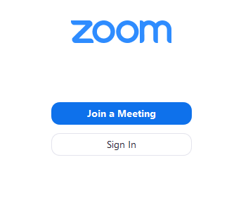
  - Sign in to Zoom then click Join.
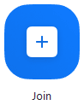
- Enter the meeting ID number and your display name.
  - If you're signed in, change your name if you don't want your default name to appear.
  - If you're not signed in, enter a display name.
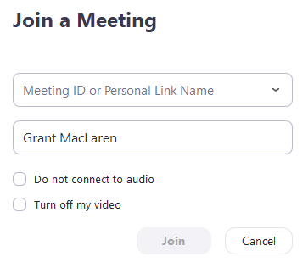
- Select if you would like to connect audio and/or video and click Join.

JOIN A MEETING

Joining the meeting or webinar
- Click the link to join the meeting.
- An option Join from your Browser may appear automatically. If it does not, select download & run Zoom.
- The option Join from your Browser will appear.
- You will be prompted to enter your name.
- Click Join to be taken into the meeting.

Join audio
Once you have joined, you can join the audio by computer, dial in by telephone, or choose call me (if enabled for the host's account). Call Me and toll-free numbers require an audio conferencing plan.
- Click Join Audio.
- Click Phone Call, Computer Audio, or Call Me tab to choose your join method.
  - Phone Call: Follow the instructions on the screen for dialing in by phone.
  - Computer Audio: Click Join Audio By Computer. After joining computer audio, you can Mute/Unmute at the lower left corner or click on the ^ to select a different microphone and/or speaker.
  - Call Me: Choose the country of the phone you are calling from the drop down. Enter the phone number. Check Remember the number on this computer if you would like this number stored for future meetings. Click Call Me.

Viewing video
When joined into a Zoom meeting from the web client, you can view one participant's video in active speaker view or if the host spotlights a video. If multiple participants are sharing their video, you will only be able to see one at a time.

Inviting others
- Click Invite to open the options to view others.
- The available options will depend on the available add-ons for your account, if you are the host, and if you are logged in.
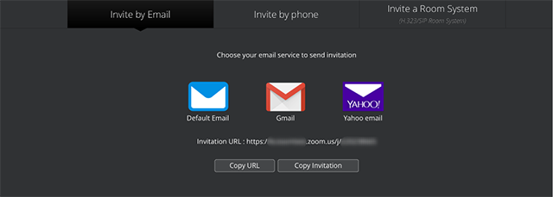
  - Invite by Email: This will open up the options to send an email with your default email client, Gmail, Yahoo email, copy the URL, or copy the entire invitation.
  - Invite by Phone: If you have an audio conferencing plan, you can call out to participants by phone. Enter the name you would like to display for them, select their country, enter their phone number, and click Invite.
  - Invite a Room System: If you have the Cloud Room Connector add-on, View the information for an H.323 or SIP room system to join the call or invite them by calling out to their IP address.

Sharing your screen
- Click Share Screen located in your meeting tool bar.
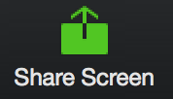
- Select the screen you want to share then click Share. If you are using multiple monitors, you will see each screen.
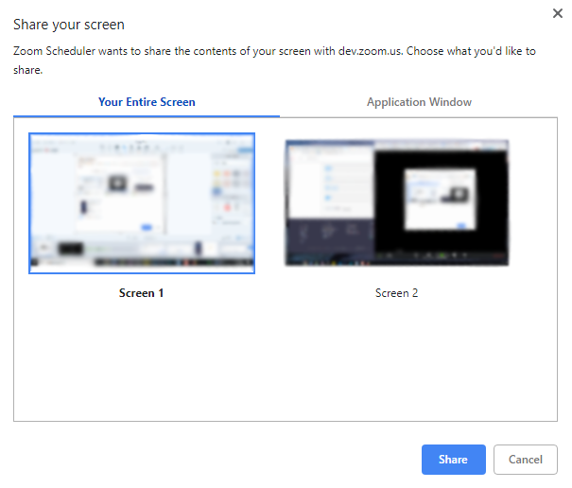To share a specific application window, click the Application Window tab, select an application, then click Share.
Notes:
  - When sharing an application, live changes made to a document may not appear for others. If you experience this issue, please stop sharing and restart the share or share your entire screen to avoid this issue.
  - For Windows 10 users, if several applications are open, a limited number will be listed as an option to share. If the application you want to share is not listed, close unnecessary applications and try again.
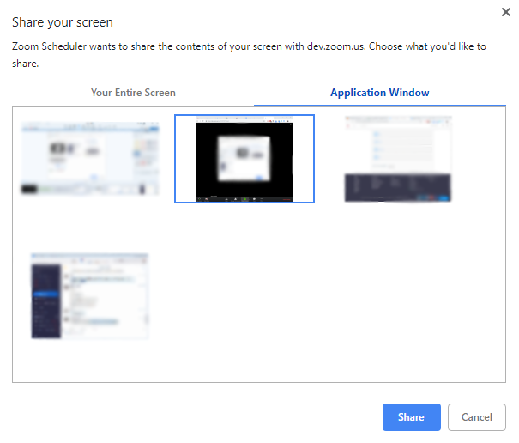
- While screen sharing, you will have access to the following controls:
  - A notification at the top of your Zoom meeting window shows a preview of your shared screen. Click Pause Share to pause screen sharing.
Click Resume Share to start screen sharing again. You can also click Stop Share to stop sharing your screen.
  - A floating notification bar appears on top of your browser. Click Stop sharing to stop sharing your screen. Chick Hide to remove the floating notification bar.
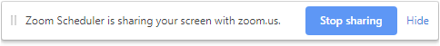
- Click the upwards arrow beside the Share screen button to change who has access to screen sharing.
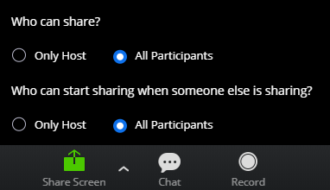

Request remote control
While another participant is screen sharing, you can remotely control their screen.
- While viewing a screen share, click Request Remote Control located at the top.
- Click Request to confirm.
- Click inside the screen share to start controlling the participant's screen.
- To stop remote control, click Give Up Remote Control at the top.

Webinar Q&A
You can ask, up vote, and comment on questions if these features are enabled by the host.
- Click Q&A in the webinar controls.
- You'll have access to the following controls:
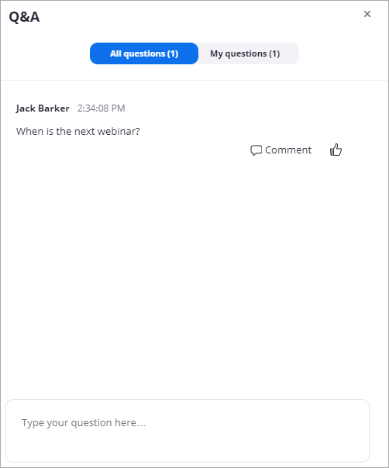
- Type your question in the text box to ask a question.
- If another participant has asked a question, click the thumbs up icon to up vote the question or click Comment. Questions are sorted based on the number of up votes.

Host controls
If you are the meeting host and are signed in to your Zoom account on the web, you will have additional options available.

Cloud recording
Click Record to start a cloud recording.

Manage participants
- Click Manage to manage the participants.
- Hover over a participant's name and click More for additional options.
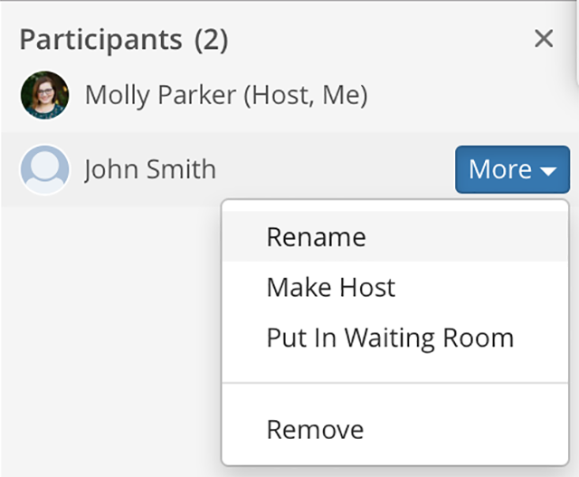
  - Rename: Change the participant's name in the meeting.
  - Make Host: Transfer host controls to this participant.
  - Put in Waiting Room: Remove this participant to the waiting room. You will then have the option to readmit them.
  - Remove: Remove this participant from the meeting.

Mute all
- Click Manage.
- At the bottom of the participants' window, click Mute All.
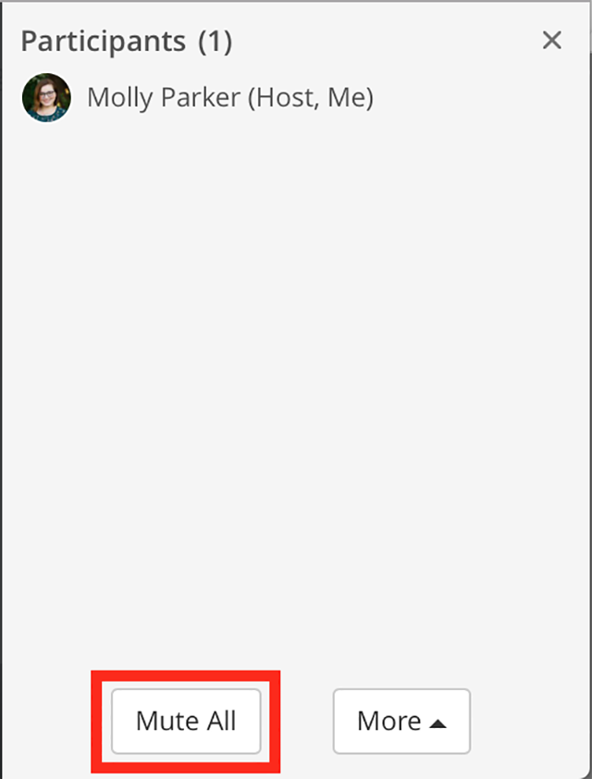

Lock meeting
Locking the meeting prevents any new participants from joining the meeting.
- Click Manage.
- At the bottom of the participants' window, click More.
- Click Lock Meeting.
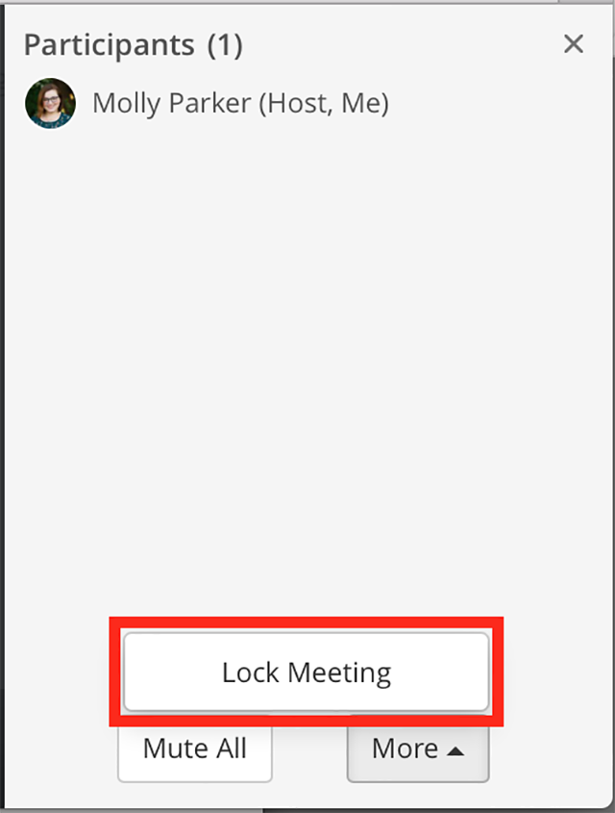

Webinar Q&A
- As the webinar host, co-host, or panelist, click Q&A in the webinar controls.
- Questions are sorted based on the number of upvotes. You'll have access to the following controls:
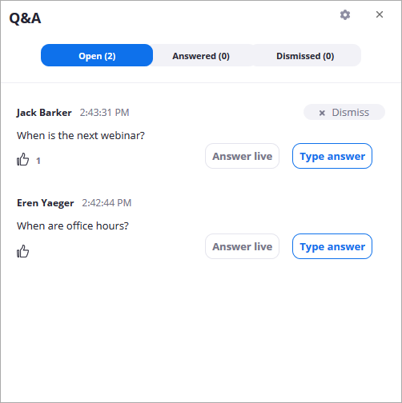
- Click Answer Live to answer the question out loud during the webinar.
- Click Type Answer to type out your answer for the attendee.
Type your answer and click Send.
(Optional): Check Answer Privately if you only want the attendee to see your answer.
- Hover over a question and click Dismiss to move the question to the Dismissed tab.
  - To reopen questions, click the Dismissed tab, find the question you would like to reopen and click Reopen Question.
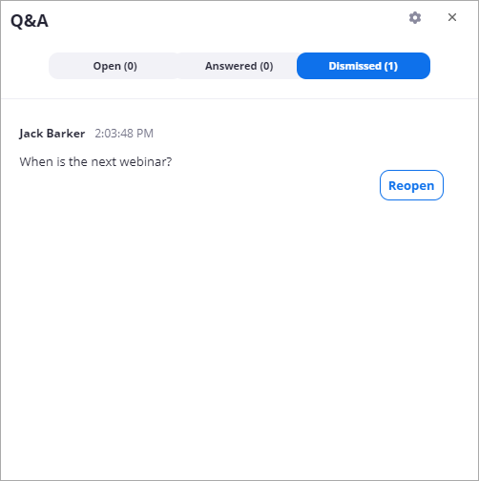
- Click the gear icon to display Q&A settings.
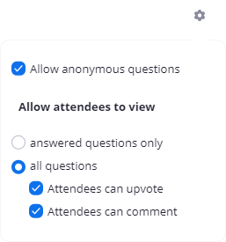
Note: If you allow attendees to answer Q&A, the questions will still appear in the Open tab, even if an attendee has commented on the question. You can answer the question by choosing Answer Live or Type Answer.

View Live Training
https://support.zoom.us/hc/en-us/articles/206618765-Zoom-Video-Tutorials

