|  |
| --- |
| Setup C:\Users\CLASTU\Pictures\ZoomLogo.png for Telemedicine Tags: Telemedicine, Zoom, EPIC  Epic EMR Component: N/A |
| **Overview:** Provides overview and walkthrough for conducting Zoom virtual visits (telemedicine).  **Audience:** Providers, Practitioners, Clinical Support |

Legend:    

Provider Staff Clinical/Nurse staff Admin Staff Support

|  |  |
| --- | --- |
|  | Pre-Requisites |

ZOOM telemedicine encounters requires:

* A webcam enabled PC or mobile device.
* Shands/EPIC credentials.

|  |  |
| --- | --- |
| cid:image001.png@01D2344E.6B9472F0 | Initial PC Setup |

**For Shands/UF Managed PC’s:**

1. On Shands managed systems, download and install the Zoom client from the Portal Manager.  
   *Note. For Portal installations, and immediate system reboot is required to complete the installation. Save your unfinished work prior to installing.*
   1. Click the Start>Portal Manager.   
      If you cannot find ‘Portal Manager,’ then click the Start button and type ‘portal manager’:  
      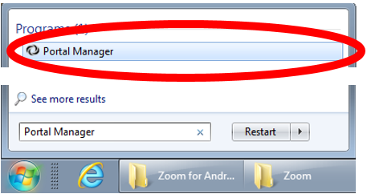  
      Click the ‘Portal Manager’ circled above to start the program.
2. Portal Manager opens. Scroll down the available app list and locate ‘Zoom – SHANDS or UF Host – Video Communications’ (cirled below)  
   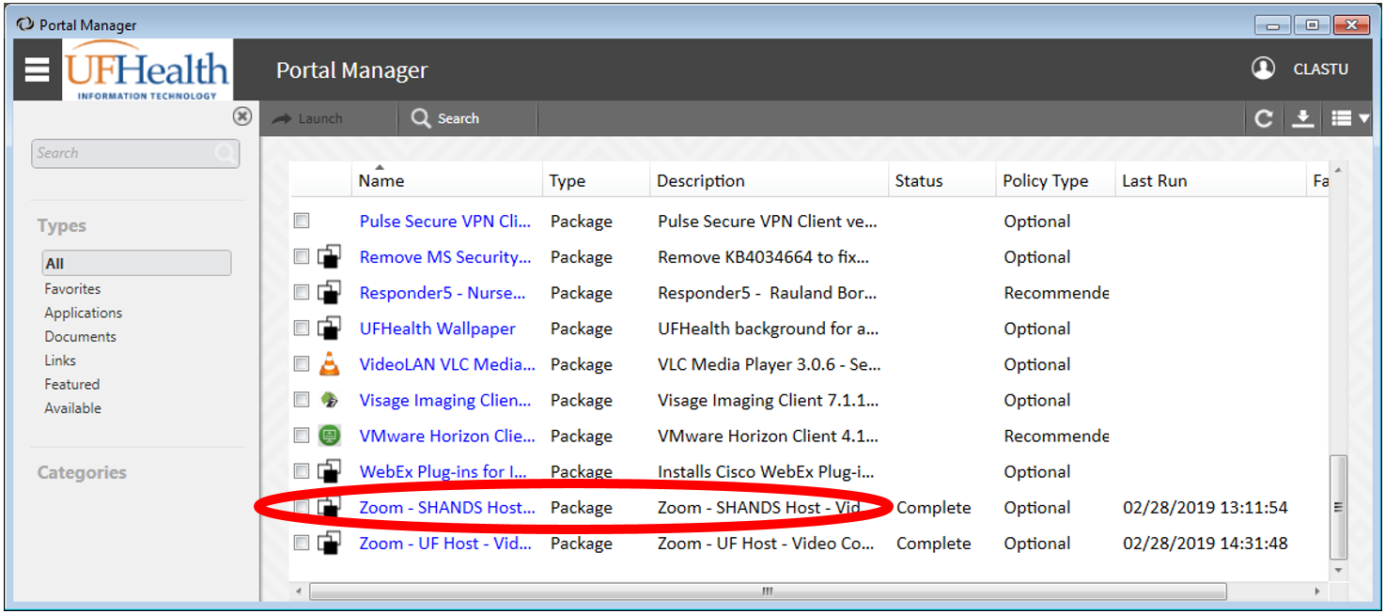
3. Click on the ‘Zoom – Shands or UF’ app and an install window will appear. Click on the blue [Install] button to begin installation:  
   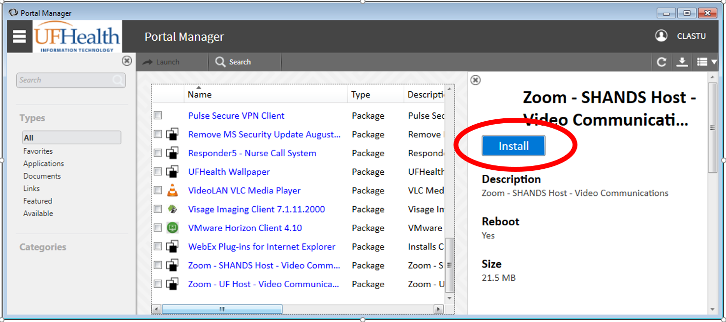
4. Please note: an immediate reboot is required to complete the installation. Your PC will ask to restart and will force restart in 10 minutes.
5. Zoom Desktop and Zoom Outlook plugin are now installed on your PC.

***Continued on next page.***

**For Personally Owned PC’s and laptops:**

1. Go to <https://ufhshands.zoom.us> using your web browser.
2. Click the blue [Sign In] button.
3. On the following page, log in using your Shands/EPIC credentials.
4. Your Zoom profile loads. In the top right of your profile page, click [RESOURCES], and then select ‘Download Zoom Client’ from the dropdown list:  
   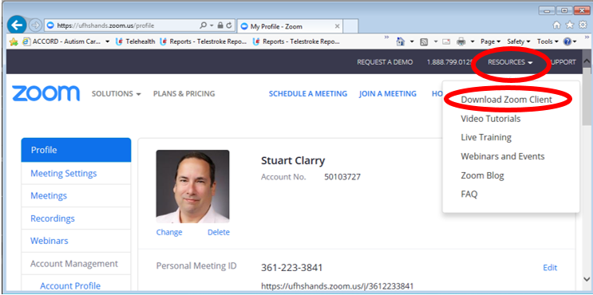
5. On the next page, click the blue [Download] button for ‘Zoom Client for Meetings’:  
   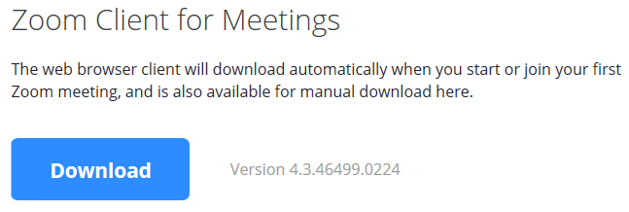  
   *Note*: If you would like to install the Zoom plugins for Outlook or Skype for Business, they are also available further down on this page.
6. When download is complete, install the Zoom client. (Select ‘Run’ if prompted).
7. Upon completion, the Zoom desktop application should start:  
   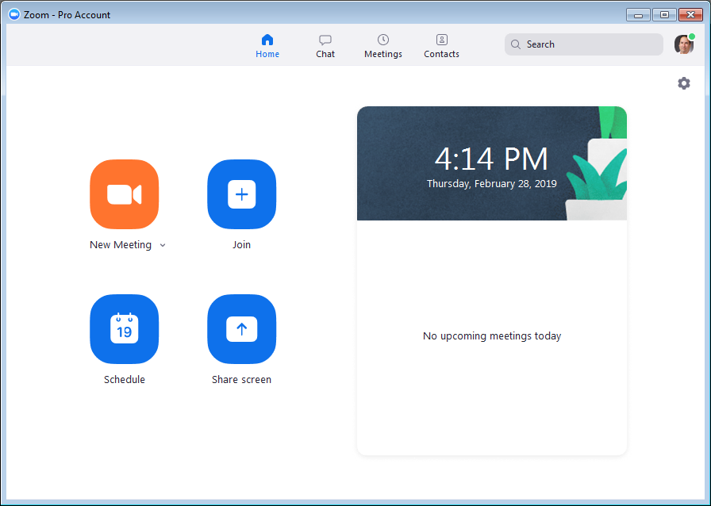
8. Zoom desktop is now installed on your PC.

|  |  |
| --- | --- |
| cid:image001.png@01D2344E.6B9472F0 | Mobile/Tablet Installation |

**Install Zoom.**

* Android: <https://play.google.com/store/apps/details?id=us.zoom.videomeetings&hl=en_US>
* iOS: <https://itunes.apple.com/us/app/zoom-cloud-meetings/id546505307?mt=8>

**Configure Zoom.**

*Note:* Process is similar for iOS and Android. Screenshots are taken from Android.

1. Start Zoom and click the [Sign In] button:  
   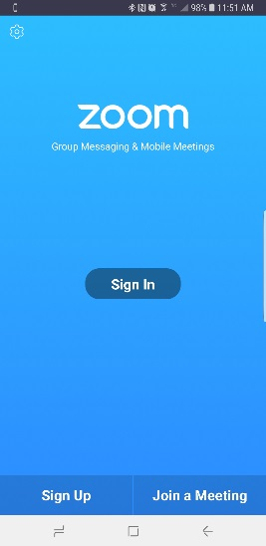
2. On the next page, do not enter your credentials.   
   Instead, click [SSO] (circled below).   
   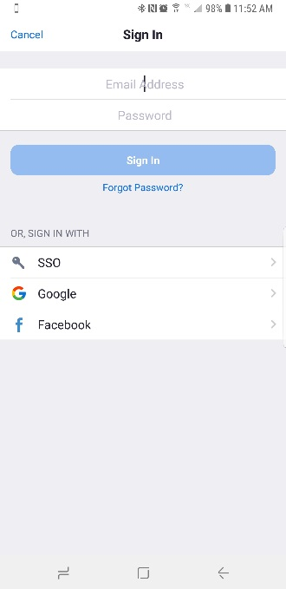
3. On the next screen, enter ‘ufhshands’ in the company domain field, and click [Continue].  
   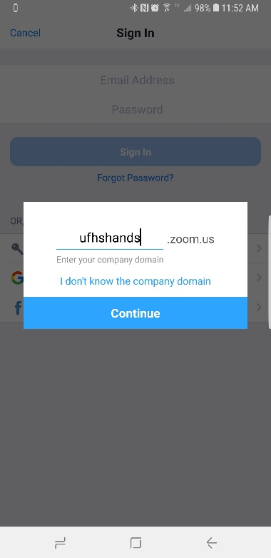
4. Enter your UF Health Shands(EPIC) credentials in the next screen. Then click [Sign In]:  
   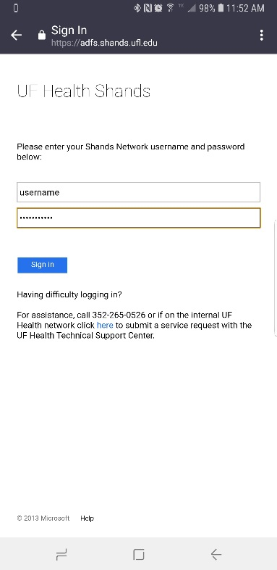
5. Zoom should start automatically. Alternately, click the blue [Launch Zoom] button on the next screen:  
   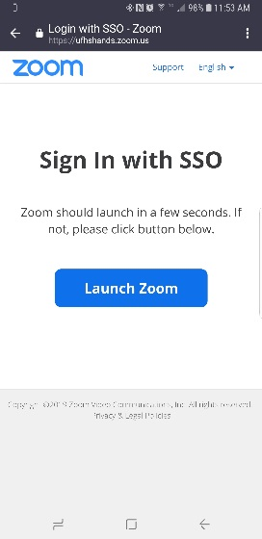
6. The Zoom App should start:  
   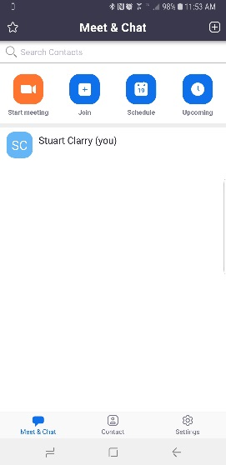

7. This completes the installation process for Zoom mobile.

|  |  |
| --- | --- |
|  | Technical Support for Telemedicine |

Please contact us if you or your patient are experiencing issues with the Zoom application.

* **For emergent issues, 24/7 tech support is available at (352) 265-8006.   
  Number can be shared with patients.**
* Alternately, please call Stuart Clarry at (352) 682-6771.
* For non-emergent issues, please email Stuart at [sclarry@ufl.edu](mailto:sclarry@ufl.edu) .
* We have set up a Zoom support call center that will be troubleshooting Zoom calls (Richard Slaughter has been doing this for the past week).  The Zoom support line number is 265-8006.  You may be getting emails (or potentially calls) from our two agents letting you know that a patient is waiting or that a patient is having technical issues and needs the physician to call him/her.  The two agents are Toccara Robinson and Jamie Zamora.